*LAB # 09*

*LAB TASKS:*

1. *write a mips assembly language program that calculates the sum of all positive even integers less than or equal to n and displays the result.*

*CODE:*

*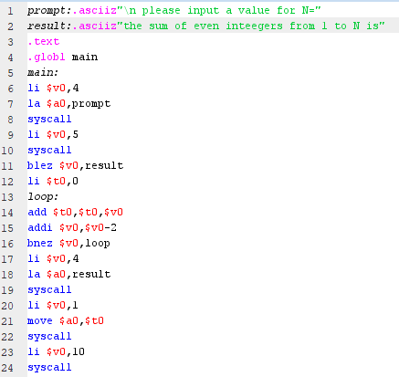*

*EXECUTION:*

*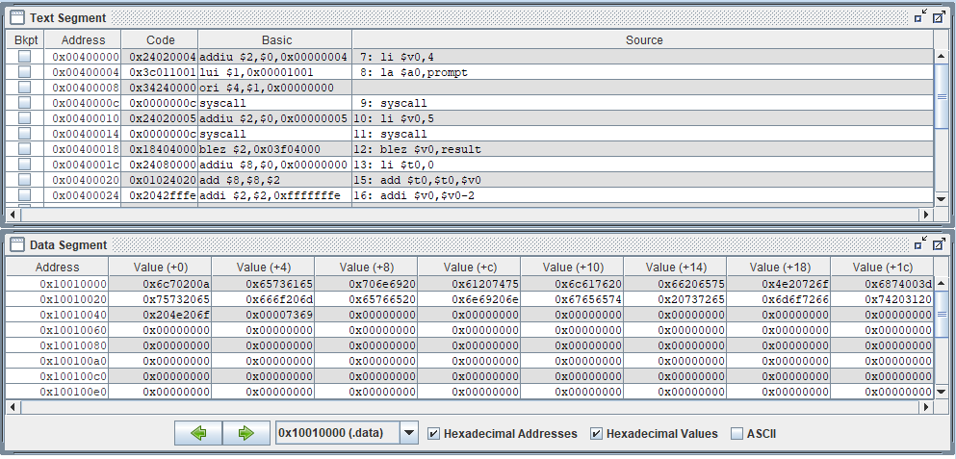*

*OUTPUT:*

*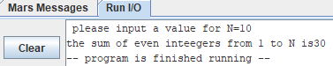*

*2. write a mips assembly program that takes an integer input and multiply that number with last digit of your roll number. display whether number is even or odd*

*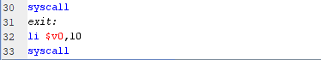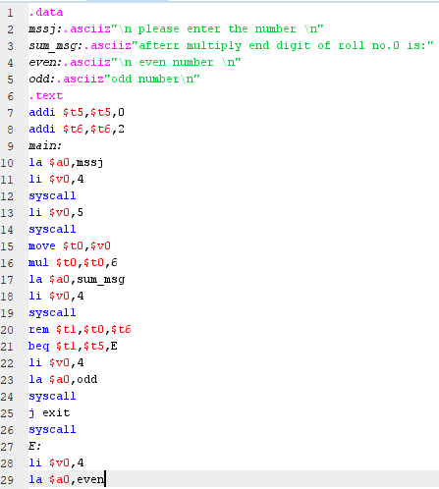*

*EXECUTION:*

*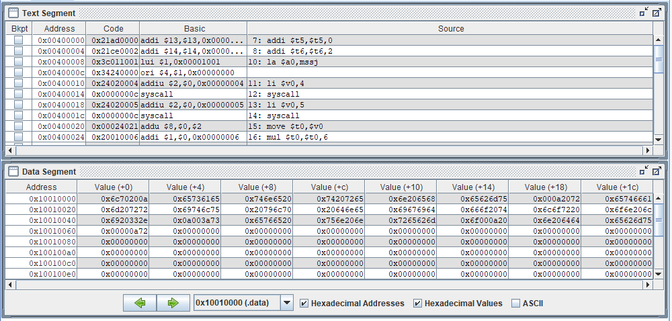*

*OUTPUT:*

*